**Inflation Forecasting in Sri Lanka: A Machine Learning Approach**

**Objective**

The primary objectives of this study were as follows:

1. To identify the most suitable univariate machine learning method for inflation forecasting.
2. To select the most appropriate multivariate machine learning forecasting method.
3. To determine the features influencing inflation forecasting in Sri Lanka.

**Data Description**

**Dataset**

Monthly data spanning the period from March 2015 to February 2024 was utilized for this analysis. A wide range of economic, financial, and production-related variables were included to ensure comprehensive coverage of factors influencing inflation. The following variables were considered:

1. **Temporal Variables:**
   * Year
   * Month
2. **Economic Indicators:**
   * Consumer Price Index (Index)
   * Treasury Bills (TB)
   * Average Weighted Lending Rate (AWLR)
   * Average Weighted Deposit Rate (AWDR)
   * Average of AWLR and AWDR
   * Average Weighted Fixed Deposit Rate
3. **Financial Indicators:**
   * Reserve Money (in Million)
   * Narrow Money Supply (M1, in Million)
   * Broad Money Supply (M2, in Million)
   * Broad Money Supply (M2b, in Million)
   * Net Foreign Assets (in Million)
   * Credit to the Private Sector (in Million)
4. **External Factors:**
   * Nominal Effective Exchange Rate (NEER Index)
   * Real Effective Exchange Rate (REER Index)
   * Monthly Average Exchange Rates
   * Brent Oil Prices (Benchmark)
   * WTI Oil Prices (Benchmark)
   * CPC Import Prices (C&F, US$/bbl)
5. **Agricultural and Environmental Factors:**
   * Rainfall
   * Vegetable Prices
   * Tea Production (Kg, in Million)
   * Rubber Production (Kg, in Million)
   * Coconut Production (Nuts, in Million)
6. **Tourism and Energy Indicators:**
   * Total Tourist Arrivals (Numbers)
   * Tourist Earnings (USD, in Million)
   * Electricity Consumption (Giga Watt Hours)
7. **Industrial and Marine Production:**
   * Marine Fish Production (Kg, in Million)
   * Inland Fish Production (Kg, in Million)

**Literature Review**

The application of machine learning (ML) techniques in inflation forecasting has garnered significant attention across various economies, demonstrating varying degrees of success.

In Russia, studies have confirmed the potential for more accurate inflation forecasts through ML methods, suggesting an enhancement over traditional models.

In the United States, research comparing ML models with time series approaches yielded mixed results: ML models outperformed in seven scenarios, while time series models excelled in nine. Notably, multivariate models, which incorporate multiple variables, provided superior forecasts in fourteen conditions, compared to univariate models that were better in only two. This underscores the importance of including diverse economic indicators beyond inflation itself to improve predictive accuracy.

Brazilian studies have demonstrated that ML methods can surpass traditional econometric models in terms of mean-squared error. The findings highlight the significance of capturing nonlinearities in inflation dynamics, with tree-based methods like random forest and XGBoost frequently ranking among the top forecasting techniques.

In Japan, the incorporation of a broader range of variables and the accommodation of non-linear relationships through ML models have led to improved near-term core inflation forecasts, particularly in the post-pandemic period.

Research focusing on Mongolia indicates that ML methods, especially XGBoost and Ridge regression, outperform traditional autoregressive models in medium-term inflation forecasting. The study also emphasizes the effectiveness of composite forecasts, suggesting that combining multiple ML techniques can serve as a viable alternative for central banks in emerging economies.

In Turkey, analyses reveal that while linear-based ML algorithms like Ridge and Lasso regression underperform compared to Vector Autoregression (VAR) models, non-linear models such as multilayer perceptron deliver satisfactory results comparable to time series algorithms. This finding suggests that non-linear ML models can be reliable supplementary tools for inflation estimation in emerging markets.

Collectively, these studies highlight the growing relevance of ML techniques in enhancing inflation forecasting accuracy. The integration of multiple economic variables and the ability to model complex, non-linear relationships contribute significantly to the improved performance of these models. As such, ML approaches present a promising avenue for policymakers and financial institutions aiming to achieve more precise inflation forecasts.

### ****Methodology****

**To evaluate the model, the dataset will be partitioned into training and test sets using a 70-30 split strategy. The first 70% of the observations will form the training set, while the last 30% of the observations will serve as the test set. Additionally, a specific subset of the data, corresponding to the original index from March 2024 to December, will be designated as the validation dataset for further model assessmen**

#### ****Machine Learning Techniques****

A variety of machine learning techniques were employed for the analysis, including Random Forest (RF), Decision Trees (DT), Gradient Boosting (GB), Extreme Gradient Boosting (XGB), Support Vector Machines (SVM), Multi-Layer Perceptron (MLP), Artificial Neural Networks (ANN), Convolutional Neural Networks (CNN), and Long Short-Term Memory (LSTM).

#### ****Model Evaluation****

Models were evaluated both with and without the application of hyperparameter tuning. For univariate time series forecasting, the same machine learning models were applied. The performance metrics used for model evaluation included Mean Squared Error (MSE), Root Mean Square Error (RMSE), Mean Absolute Error (MAE), Mean Absolute Percentage Error (MAPE), and R-squared (²). Higher R-squared values, alongside lower values for MSE, RMSE, MAE, and MAPE, were considered indicative of superior model performance.

#### ****Hyperparameter Tuning****

Hyperparameter tuning was conducted using methods such as Random Search, Grid Search, and Bayesian Optimization (e.g., Optuna). Models were fitted with and without hyperparameter optimization to compare their performance under different conditions.

Results.

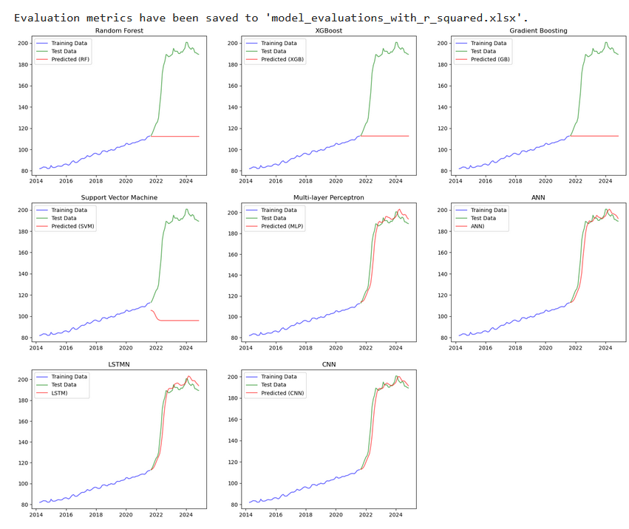

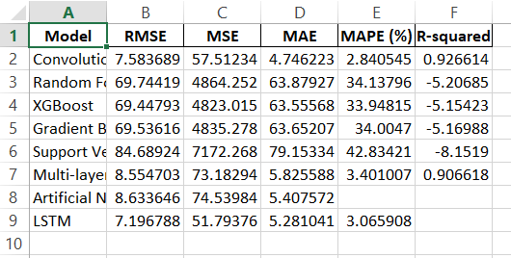

Based on the above analysis, CNN has been identified as the optimal model due to its lower MAE and MAPE values. Additionally, it was observed through visualizations that CNN approximates the test data more effectively. This performance can be attributed to its ability to capture non-linear patterns in the data."

Hyperparameter Tuning with grid search

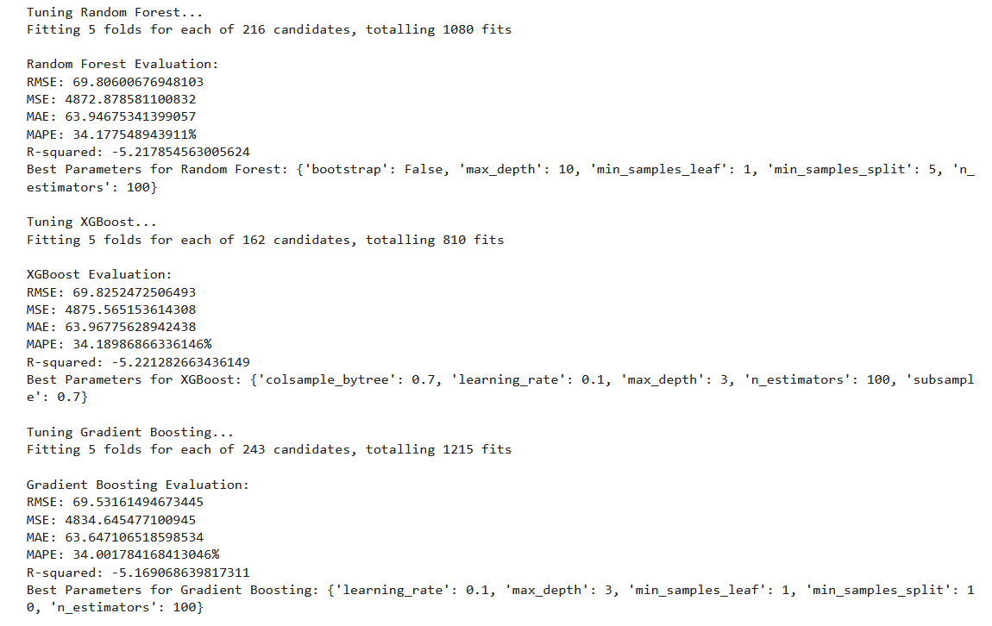

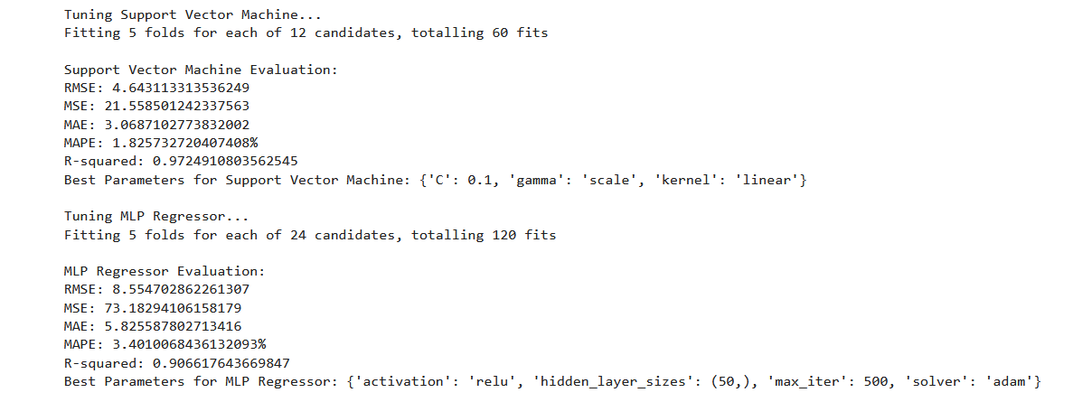

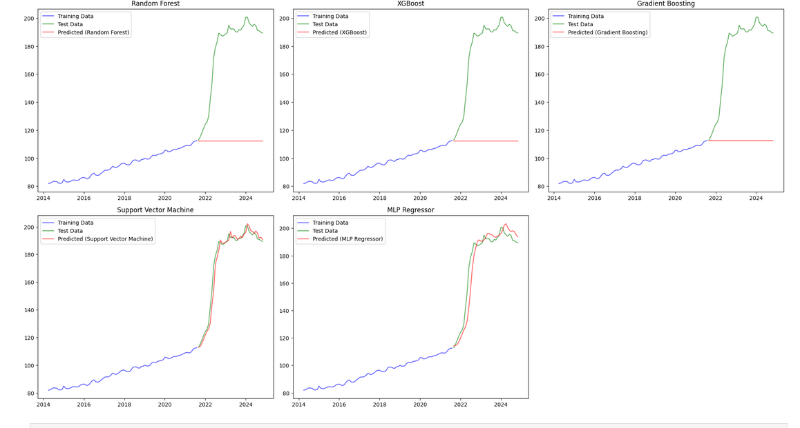

The Support Vector Machine (SVM) model, configured with optimal hyperparameters—specifically, a regularization parameter (C) of 0.1 and a linear kernel—has demonstrated superior performance across multiple evaluation metrics. These metrics include the lowest values for Root Mean Squared Error (RMSE), Mean Squared Error (MSE), Mean Absolute Error (MAE), and Mean Absolute Percentage Error (MAPE), as well as the highest R-squared value among all models evaluated to date.

Hyper parameter tuning with Optima.

DT  
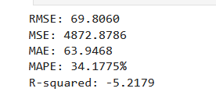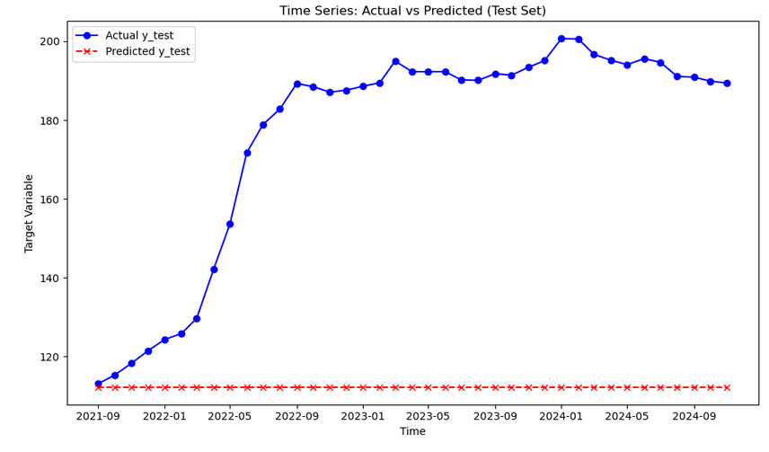

RF

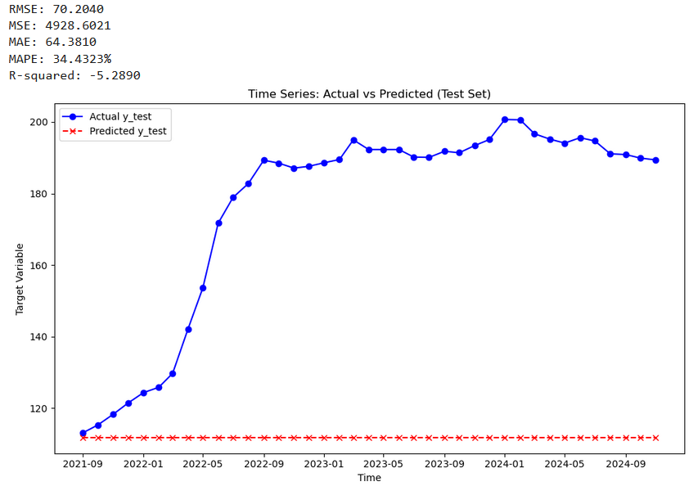

XGB

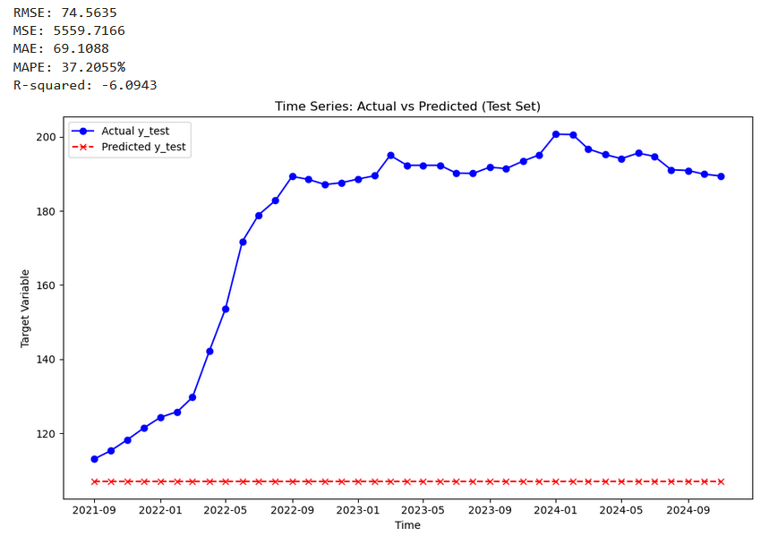

SVM

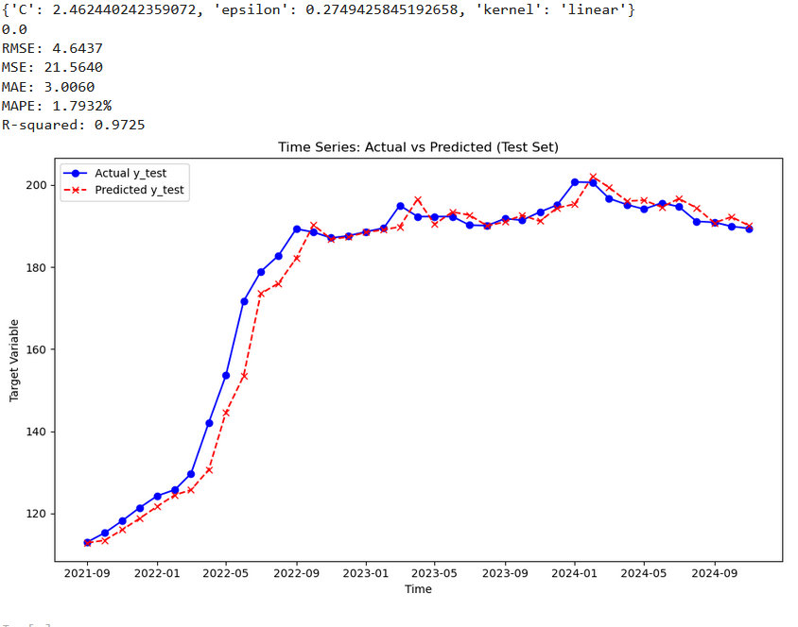

Using **Optuna hyperparameter tuning**, the Support Vector Machine (SVM) model demonstrated the **best performance** among all models evaluated so far, with the **highest R²** and the **lowest MAE and MAPE**. This conclusion is also supported by visual comparisons, which indicate the SVM's superiority.

However, when comparing the **second and first optimal models**, the differences in performance metrics are **minimal**, often observable only from the **fourth decimal point onward**. This indicates that while SVM achieved slightly better results, the improvement over the other two methods is marginal in practical terms. This suggests that the **third method** might still be a strong contender for consideration, especially in scenarios where computational efficiency or model simplicity is prioritized.

References

https://elibrary.ru/item.asp?id=37181705

https://link.springer.com/article/10.1007/s00521-016-2766-x

https://www.sciencedirect.com/science/article/pii/S2666143823000042

https://www.imf.org/en/Publications/WP/Issues/2024/09/27/Mending-the-Crystal-Ball-Enhanced-Inflation-Forecasts-with-Machine-Learning-552848#:~:text=Machine%20learning%20models%20can%20improve,inflation%20in%20Japan%20post%2Dpandemic.

https://arxiv.org/abs/2308.11173

https://onlinelibrary.wiley.com/doi/abs/10.1002/asmb.2757

https://onlinelibrary.wiley.com/doi/full/10.1002/jae.3088

https://link.springer.com/article/10.1007/s10614-023-10436-w

https://www.pp.u-tokyo.ac.jp/wp-content/uploads/2016/02/R3_Batbold-Narmandakh.pdf

https://link.springer.com/chapter/10.1007/978-3-030-56219-9_24

https://avesis.hacettepe.edu.tr/yayin/0be8e2c2-a53e-4a97-91e1-684d3f44d02e/forecasting-inflation-in-turkey-a-comparison-of-time-series-and-machine-learning-models